Configuring an Amazon EC2 Instance

Alen Ovalles

Purpose

The purpose of this lab is the introduction to what an EC2 instance is in AWS. In this lab, we will launch and configure an Amazon EC2, troubleshoot the EC2, update the security groups, create and test a rule and resize an instance.

Process with Pictures

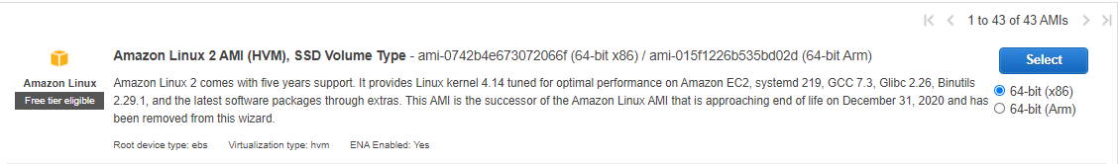**Step 1:** Launch an instance from the Amazon EC2 dashboard and select the Amazon Linux 2 AMI (HVM)

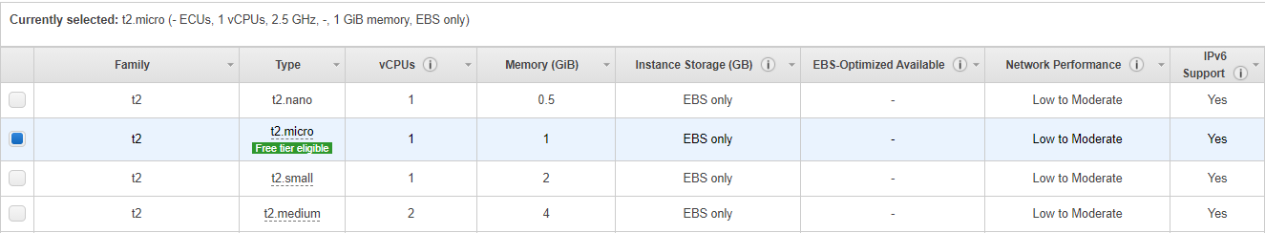**Step 2:** Select the t2.micro instance, it should be the default selection

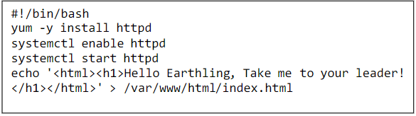       **Step 3:** Configure advanced instance details, in the user data box type the following text

**Step 4:** Add a tag; Key: *Name* | Value: BitBeat *WebServer*

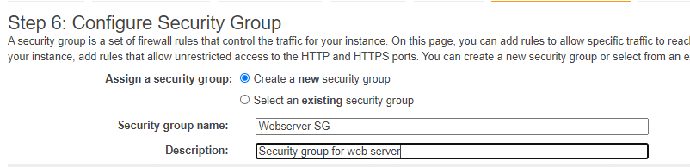**Step 5:** Configure security groups; SG Name: *Webserver SG* | Description: *Security group for web server*

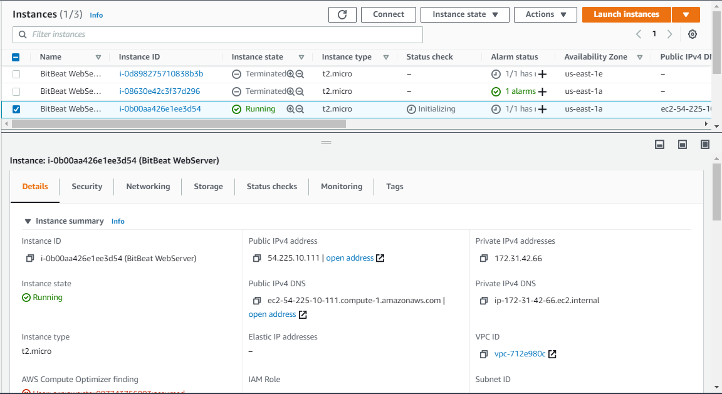

**Step 7:** Update security groups by clicking on the Security Tag while highlighting created instance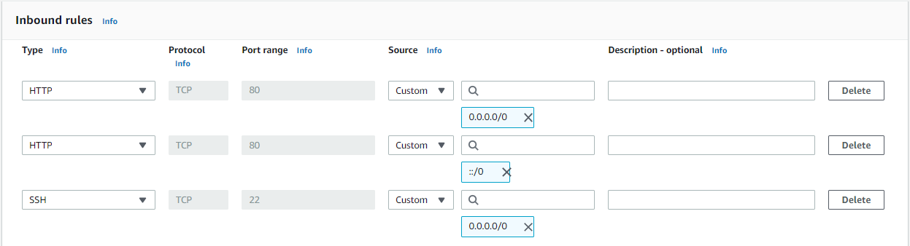**Step 8:** Create/Add rule; Type: *HTTP* | Source: *Anywhere*

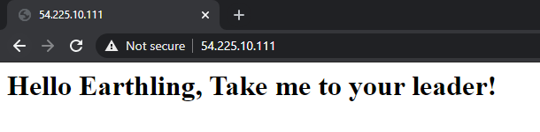

**Step 9:** Testing rule; type http://[ip address] into search bar, should see the message above

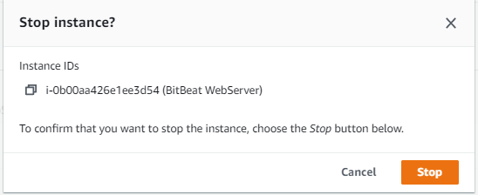

**Step 10:** Stop the Amazon EC2 instance for cost effectiveness; While highlighting the instance click *Actions > Instance State > Stop*

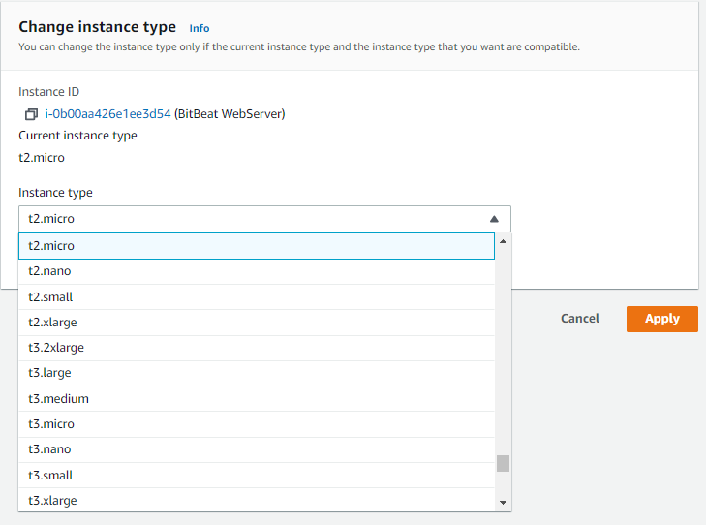**Step 11:** Resize instance; Highlight instance, *Actions > Instance > Change Instance Type > t2.small*

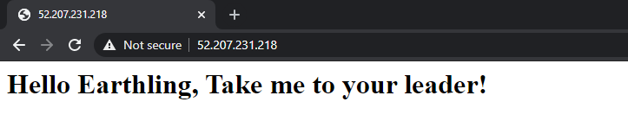**Step 12:** Start resized instance and repeat **Step 9** and **Step 10** when done

Problems

One problem was with getting the Html website to load on chrome. After a talk with classmates and teacher, found that by typing in “http://[ip address]” the link would function correctly. We found that chrome didn’t allow the ip address connection without the specifics of it either being http or https. In the steps, there is shown where we added the http to the EC2 instance, so adding the http would make sense in the search bar for the ip address. Another problem that arose was a step (#3) that made us manually type in the text for a user data box. The problem was with the picture of the pdf that was difficult to enter the right spacing for the user data. A solution was to find the same lab documentary online and use that picture, and I did find a clearer picture than the pdf that was given to use.